**Assembly Homework Ch 6**

**Your Name:謝豐安 Student ID (學號):A1055548**

1. Print your executing results 20% (貼上執行結果20%)

Problem1

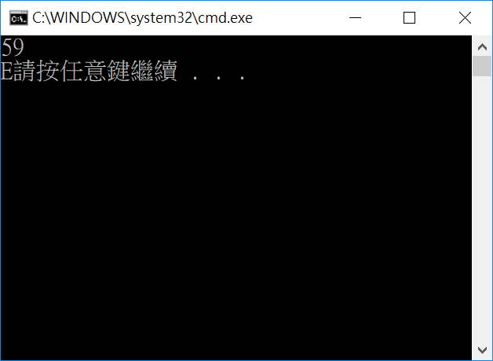

2. Source Code 20% and Comments 60% (程式原始碼20%與程式註解說明50%)

INCLUDE Irvine32.inc

.386

.model flat,stdcall

.stack 4096

ExitProcess proto,dwExitCode:dword

.data

ChooseL BYTE "EEEEEEEEEEEEEEEEEEEEEEEEEEEEEEEEEEEEEEEEEEEEEEEEEEEEEEEEEEEEDDDDDDDDDDCCCCCCCCCCBBBBBBBBBBAAAAAAAAAAA",0

ErrL BYTE "Error input.",0

.code

Cla PROC

mov esi , eax

mov al , ChooseL[esi]

call WriteChar

ret

Cla ENDP

main proc

Call ReadInt ; Read score

Test1:

cmp eax , 100 ;if>100 show error msg

jg Err

jmp Test2 ;check whether < 0

Test2:

cmp eax , 0 ;if < 0 show error msg

jl Err

pushad ;save all reg

call Cla ;call procedure

popad ;restore all reg

jmp next

Err:

mov edx , offset ErrL

call WriteString

call Crlf

jmp Next

Next:

exit

main endp

end main

1. Print your executing results 20% (貼上執行結果20%)

Problem2

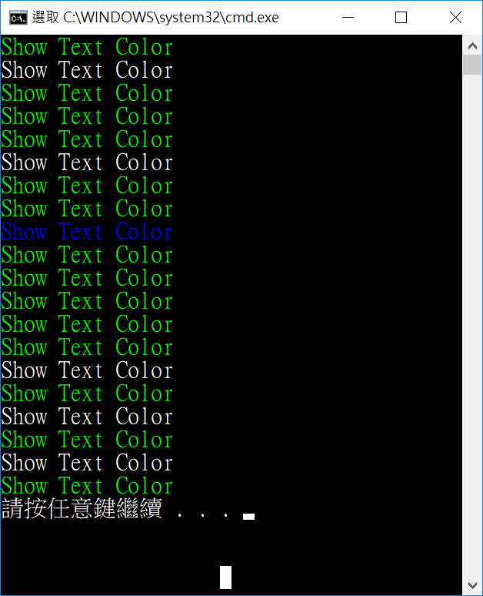

2. Source Code 20% and Comments 60% (程式原始碼20%與程式註解說明50%)

INCLUDE Irvine32.inc

.386

.model flat,stdcall

.stack 4096

ExitProcess proto,dwExitCode:dword

.data

CoLoR BYTE 15,15,15,9,10,10,10,10,10,10

Str1 BYTE "Show Text Color",0

.code

main proc

mov ecx , 20 ;loop times

mov edx , offset Str1 ;the string we want to show

L1:

mov eax , 10 ;range of random

call RandomRange ;store a number between 0~9 in eax reg

mov esi , eax ; move index pos

movzx eax , CoLoR[esi] ;choose color

call SetTextColor ;setcolor

call WriteString ;show text

call Crlf ;new line

loop L1

mov eax , 15 ;white color

call SetTextColor ; restore color

exit

main endp

end main